FAGLL03-G/L LINE ITEM DISPLAY - FOR DISPLAY OF FUNCTIONAL AREA ADJUSTMENT POSTINGS


The purpose of this simulation is to show how to use T-Code FAGLL03 - G/L Line Item Display report to check the postings made by Functional Area Adjustment process (ZFGL01 in ST and/or TX ledger(s) only). This is based on the specific features of such documents.

There is a separate simulation describing the general functionalities of T-Code FAGLL03 if you need further general information about FAGLL03.

Click to continue.

Explanation | Screenshot
[1] FAGLL03 is now entered in the Transaction box. | 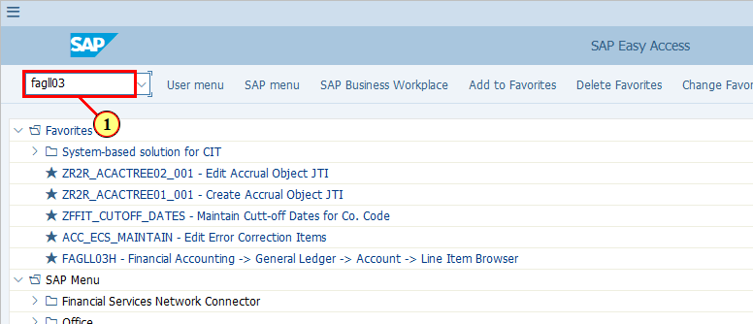
  In FAGLL03 - G/L Line Items report, we would like to see the postings made via Functional Area Adjustment ZFGL01.  There are many ways you can find such documents, for example:  - You can use Document Numbers from the ZFGL01 log as an additional selection criterion, if you have the log.  - You can put the G/L accounts used, together with the posting date range as selection criteria.  - If you know the original FI document numbers based on which the Functional Area Adjustments were posted, you can put those document numbers as Reference to search for line items posted with those documents as reference documents.  - You may also use Document Type as we know Functional Area Adjustments are posted with Document Type SA unless you specify using the original Document Type. However, you should note that there are also other transactions posting documents with Doc Type SA, such as AP/AR Regrouping for 3rd party vendors/customers.  If you do not have much details related to the above, you can simply use a G/L account range. As we know that all the Functional Area Adjustment postings are made using specially defined accounts, which are in the range of 891000-899999. In this simulation we will be using this G/L account range for demonstration.  Click to continue.  [2] The G/L account field is filled out. | 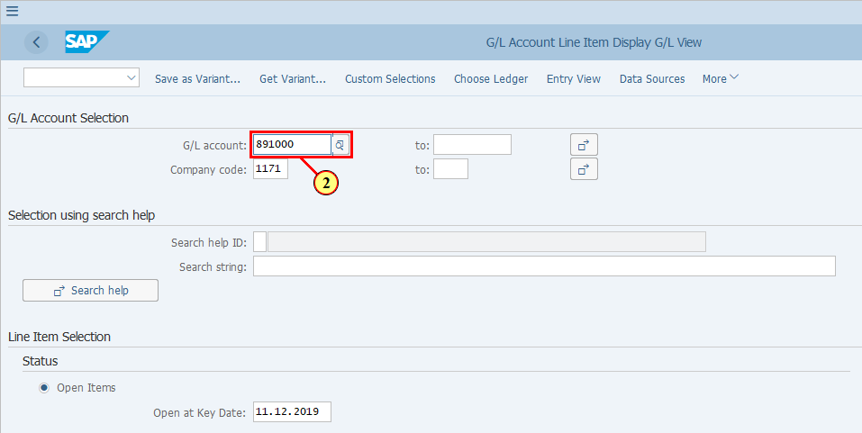
[3] The to field is filled out. | 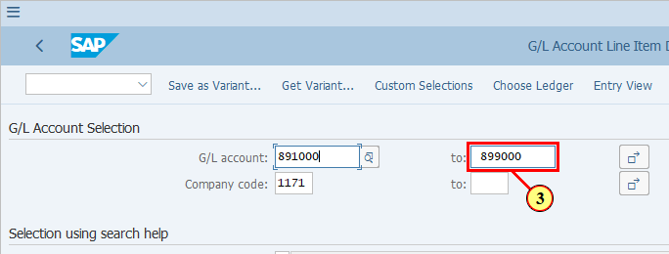
[4] The Company code field is filled out. | 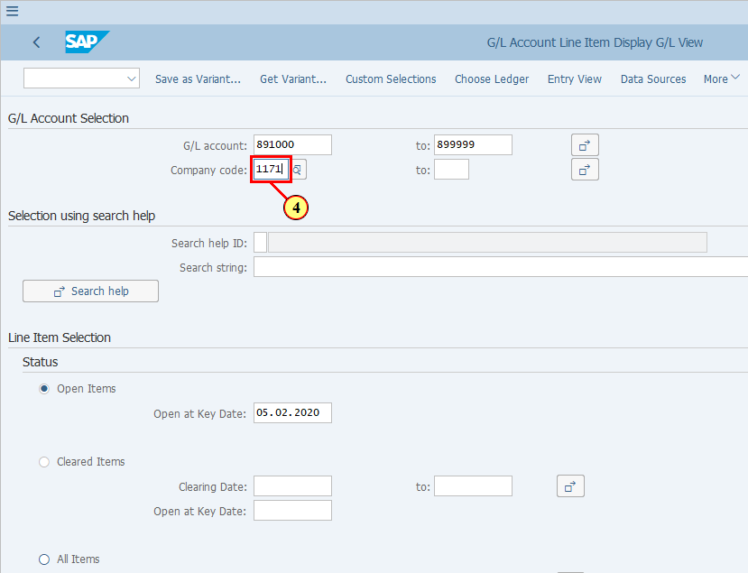
[5] All Items is now selected. | 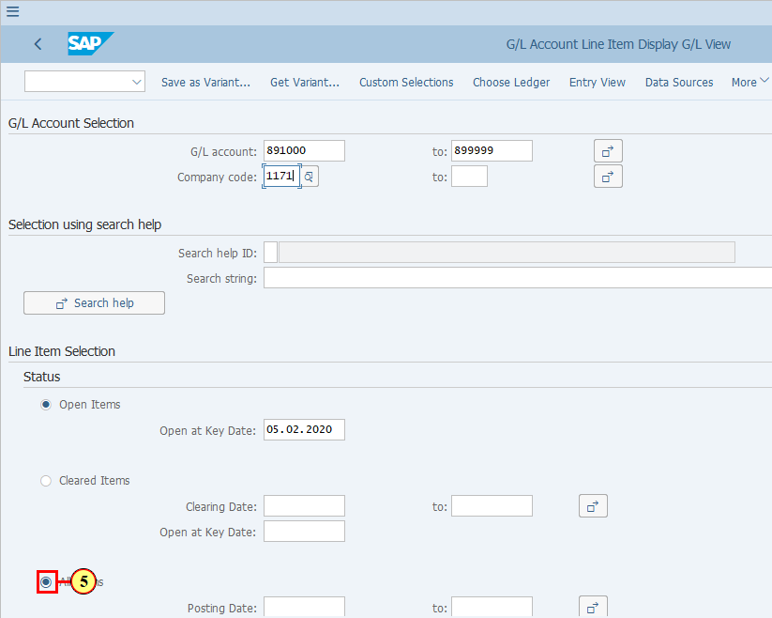
  The Posting Dates used in Functional Area Adjustment documents are not the last date of the period but the same dates as in the Posting Date field of the original documents where P&Ls were posted. Therefore we will put the date of current posting period here.  [6] The Posting Date field is filled out. | 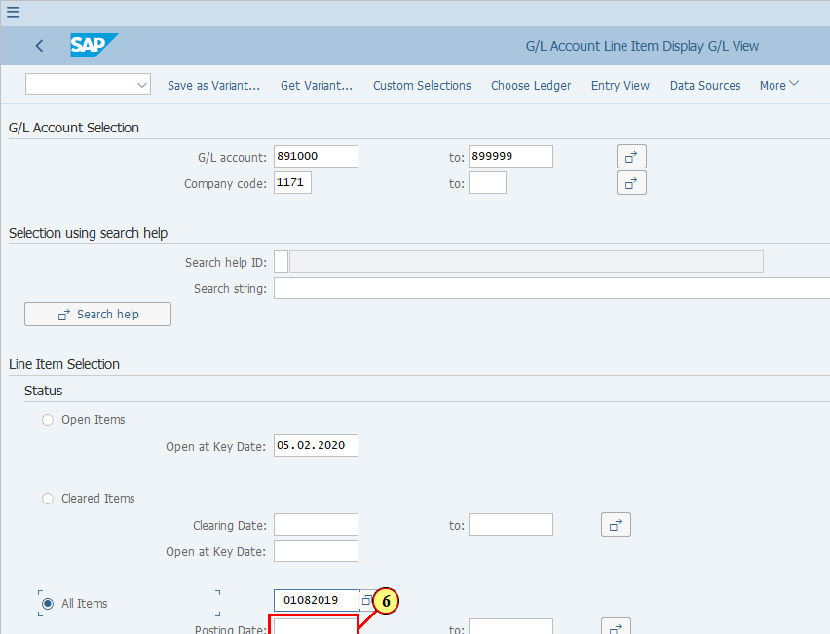
[7] The to field is filled out. | 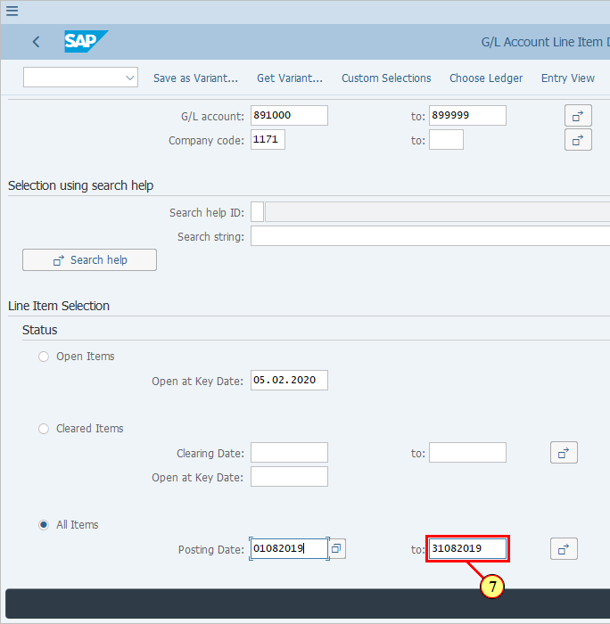
 | 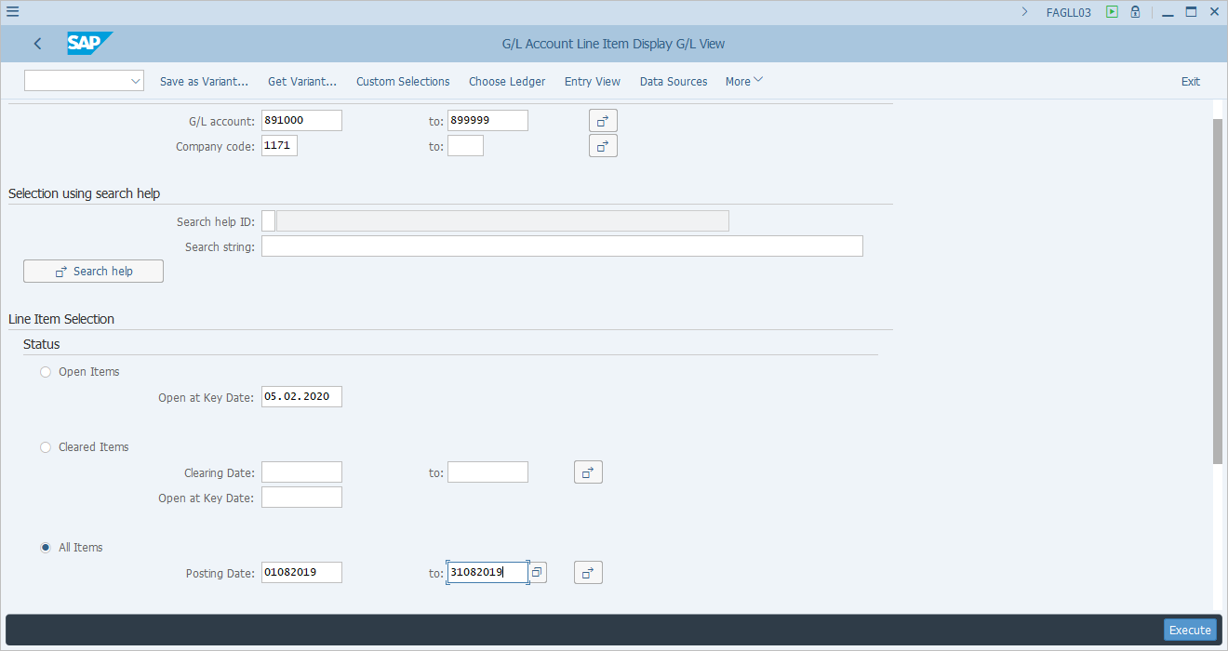
  Functional Area Adjustment postings are made to the required Statutory and/or Tax ledgers based on entity requirements. By default the FAGLL03 shows Ledger 0L. You will need to change this to either ST or TX in order to find the required Functional Area Adjustment documents.  [8] Click Choose Ledger .  You can also press Ctrl+F3. | 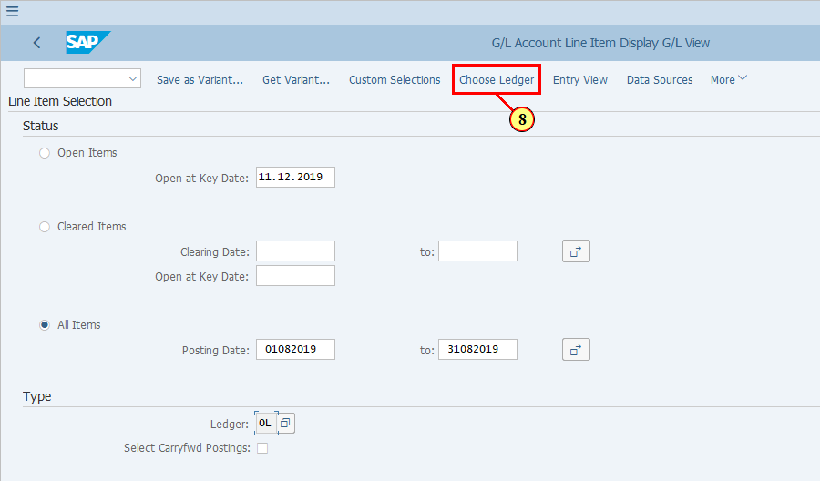
[9] The *Ledger field is filled out. | 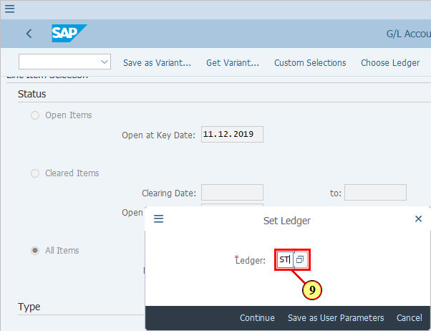
[10] Click Continue .  You can also press Enter. | 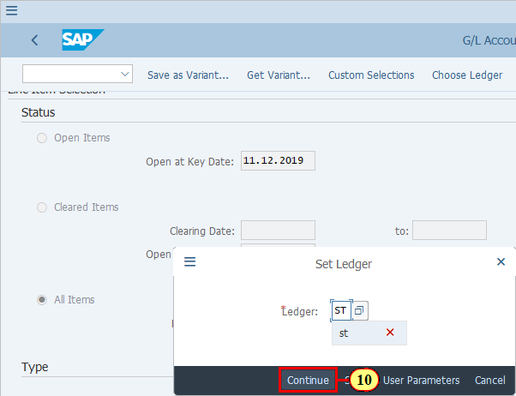
  Layout is optional. You may use the default suggested by the system or choose your own layout which contains the required columns that you wish to see. You can still change layout when you are inside the report.  [11] The Layout field is cleared. | 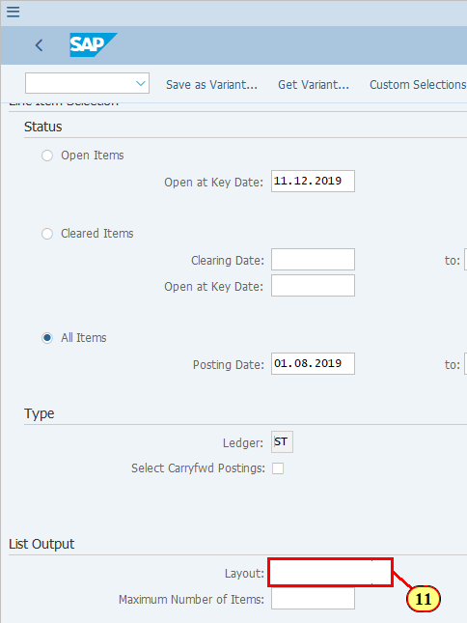
[12] Click Execute .  You can also press F8. | 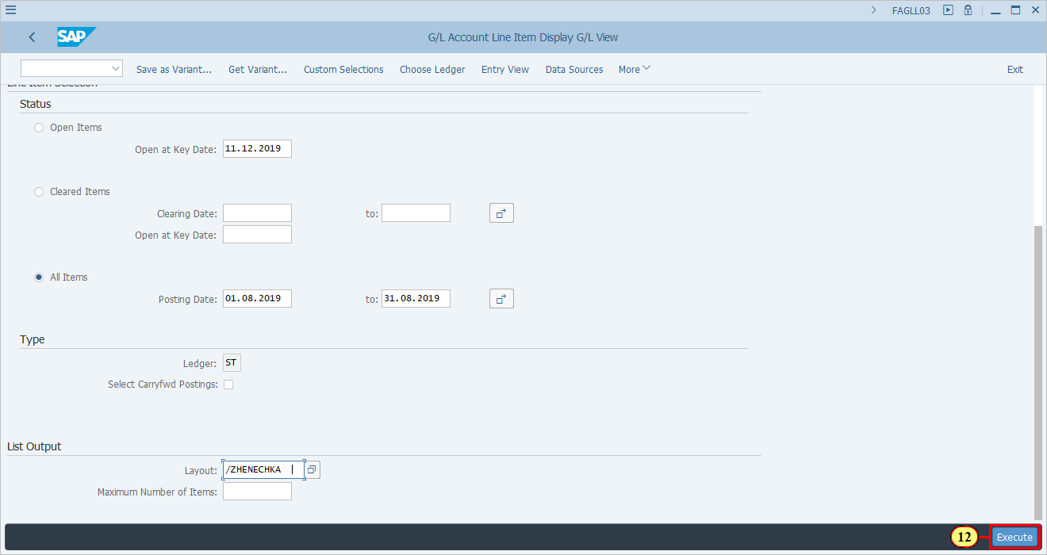
  If you need to change the layout, do so by using the corresponding icon from the menu.  [13] Click Change Layout... .  You can also press Ctrl+F8. | 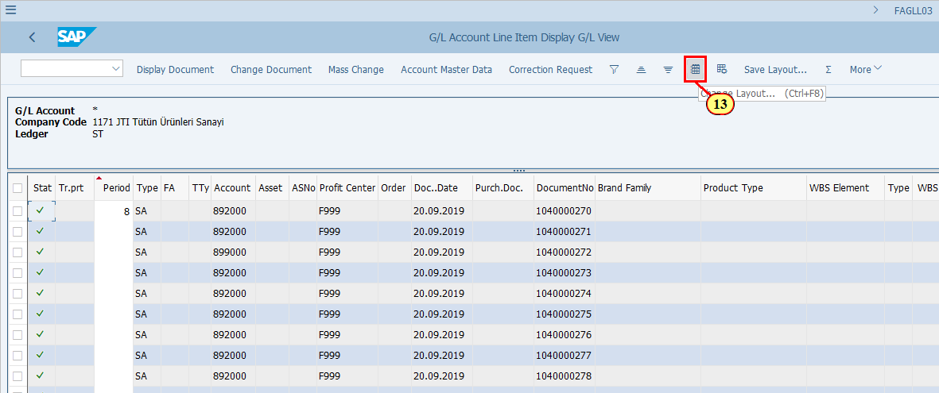
  The followng fields may help you to easily identify and validate the postings from Functional Area Adjustments.  - Transaction Code  - Account  - Document Type  [14] Click Transfer .  You can also press Enter. | 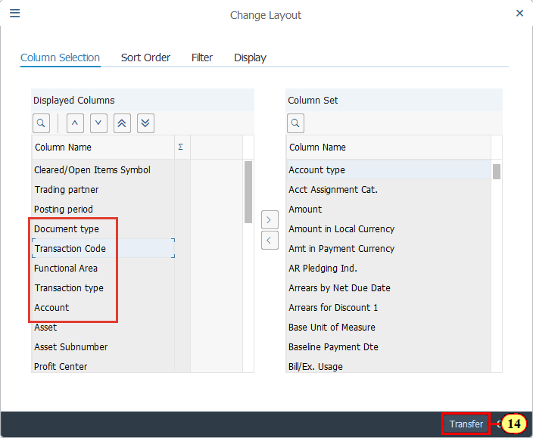
  The followng fields may help you to easily identify and validate the postings from Functional Area Adjustments.  - Transaction Code: Always ZFGL01 for the normal postings. However there may be FB08 postings if you have reversed the Functional Area Adjustments, which should be taken into account if you are reviewing the overall situation of the Functional Area Adjustments.  - Account:891000 - 899999  - Document Type: SA for majority of the cases unless an entity specifically requested Functional Area Adjustments to be posted with the same Document Types as the original documents.  Click when you are ready to continue.  [15] Let's take a look at an example document from the list.  Click DocumentNo . | 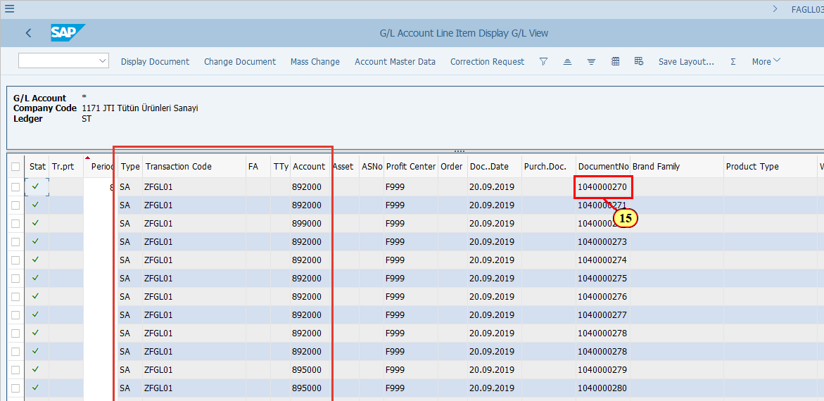
[16] Click Display Document .  You can also press Ctrl+Shift+F7. | 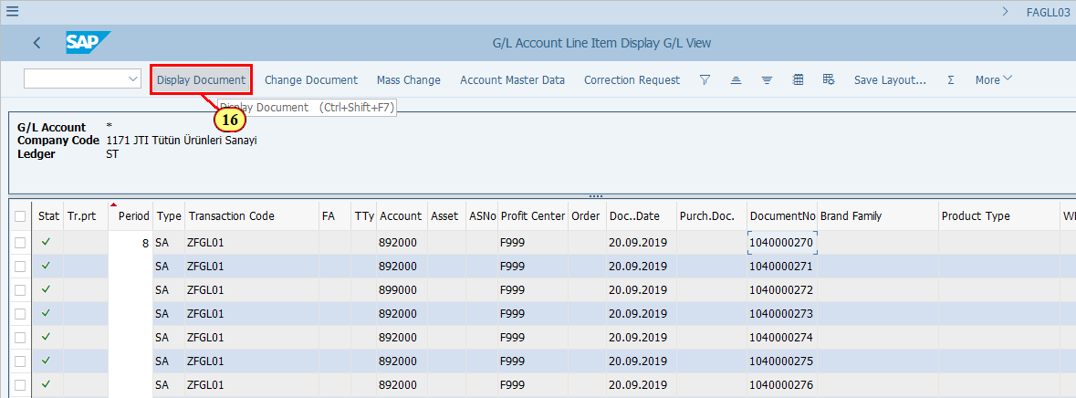
[17] Click Call Up Document Overview .  You can also press F9. | 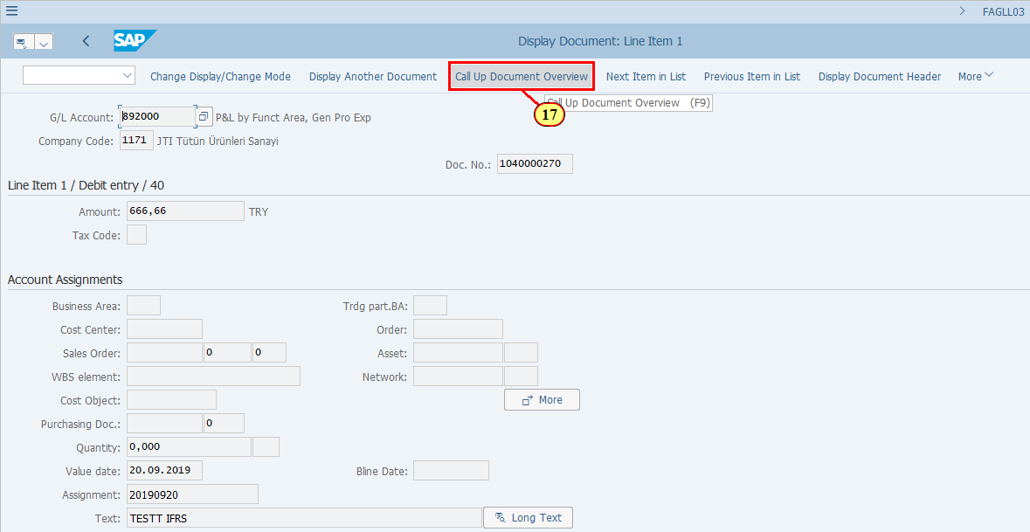
  This is the Functional Area Adjustment document.  You may validate the following key information, which is based on ZFGL01 execution:  - Company Code  - Ledger  - Document Date - the date when you executed ZFGL01  - Debit/Credit G/L accounts used for posting (Postings are between a Functional Area Adjustment account representing a specific Functional Area such as 891000, 892000, etc. and a balancing account 899999.)  The following information is based on the original P&L document:  - Posting Date / Posting Period  - Reference (original document number)  - Currency  - Amounts  - Profit Center  You can use all the above fields to filter and search for any specific Functional Area Adjustment postings back on the FAGLL03/FAGLL03H report.  Click on when you are ready to continue.  [18] Click Display Document Header .  You can also press F5. | 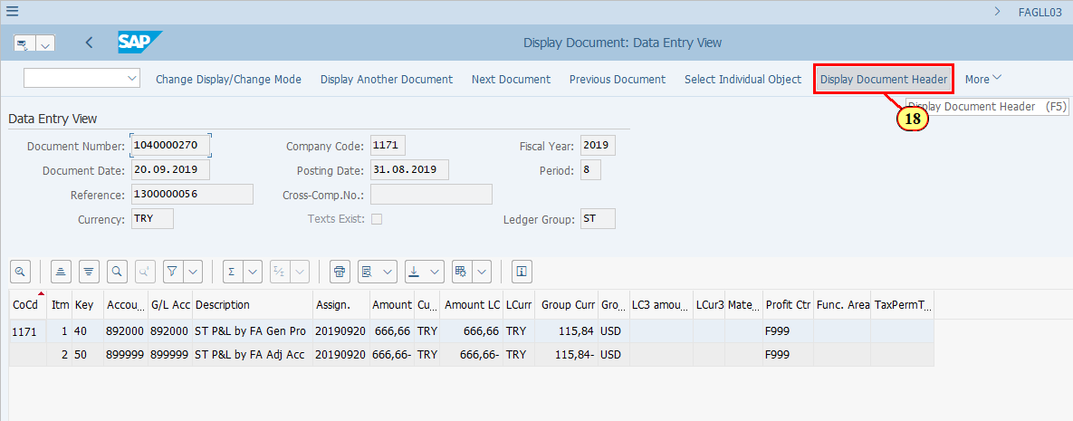
  Further in the Document Header you can find that Doc.Header Text field inherits the same Doc.Header Text of the original document. | 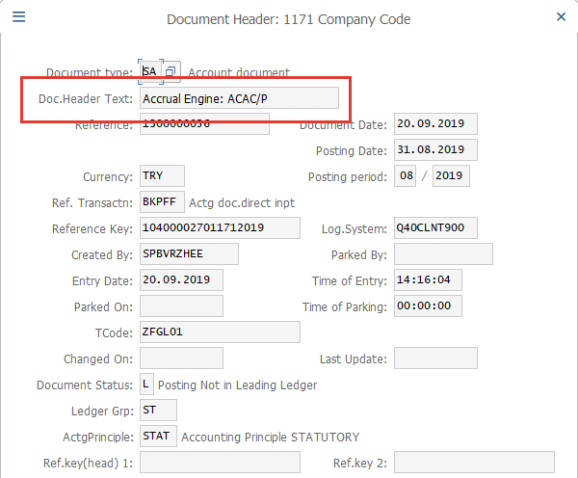
  Tcode is always ZFGL01 for documents posted via the monthly Functional Area Adjustment run. Remember to take into consideration of reversal documents posted via FB08 if you are doing an overall review, | 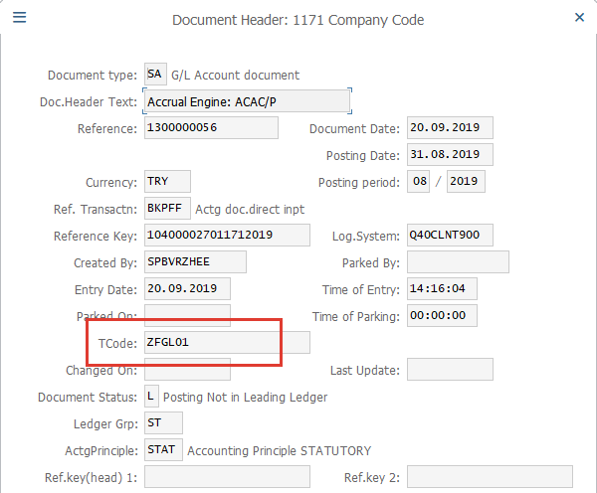
[19] Click Continue/Confirm .  You can also press Enter. | 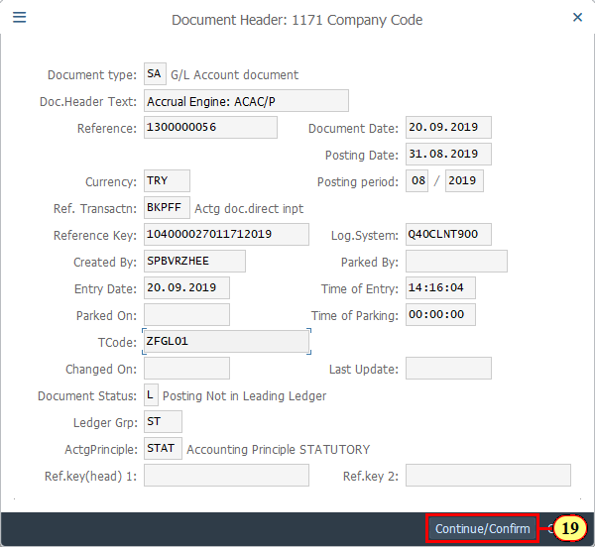
  You can see the document is posted to Ledger Group ST. Switch to Ledger View to see postings in different ledgers. It should have been posted to Ledgers ST and S1 in this case.  [20] Click More . | 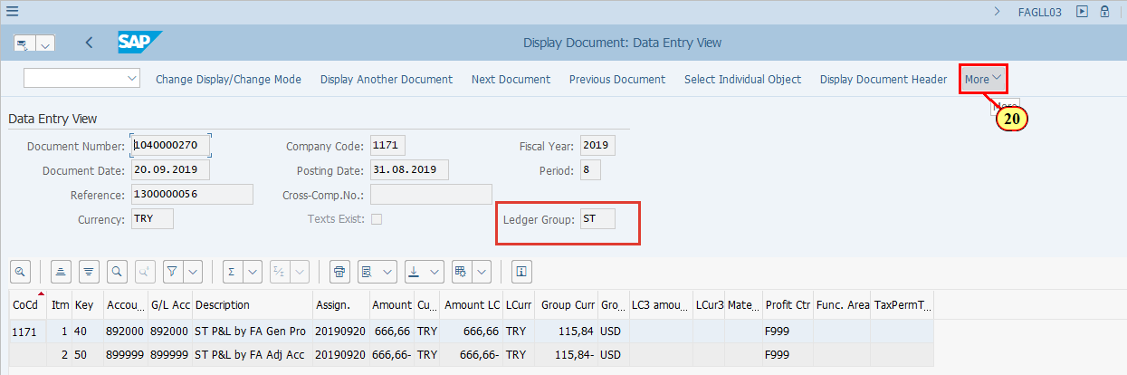
[21] Clicking the entry selects it. | 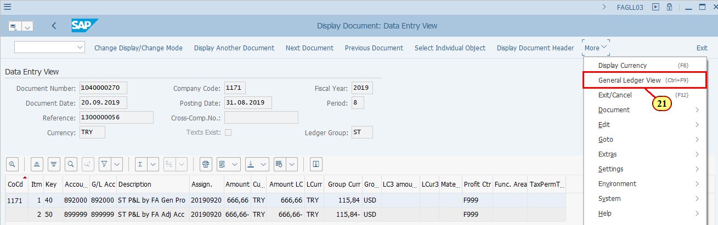
  Here is the Ledger View for Ledger ST. You can use Other Ledger button to switch to Ledger View for Ledger T1.  [22] Click Back .  You can also press F3. | 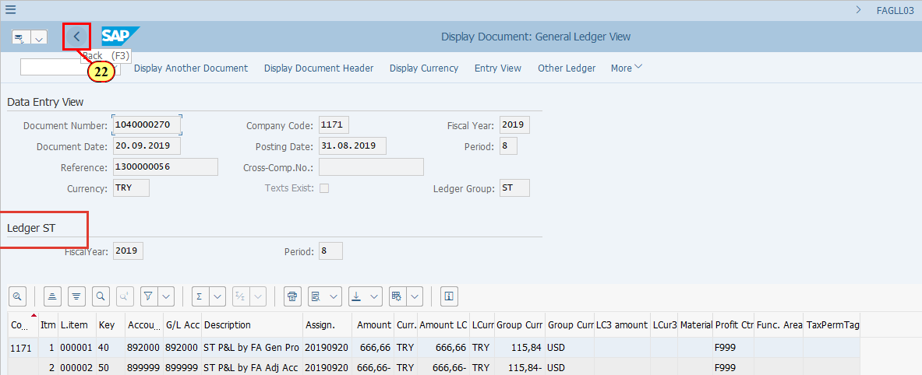
  Remember when we executed FAGLL03 report, we only restricted G/L accounts for the current period postings. You should also know that although majority of the G/L accounts within the range of 891000-899999 are for Statutory/Tax Functional Area Adjustments, there are some accounts for other purposes (e.g. technical accounts) as well.  As you can see here, in this specific example of entity 1171, which has special Year End transactions posted with Document Type T2, also using G/L in the range of 891000-899999. However, G/Ls 893008 amd 893009 are not posted via ZFGL01 process.  Therefore when you are reviewing Functional Area Adjustment postings, you should be looking at a number of different fields to ensure you find the required documents. In this example, those documents posted with Document Type T2 and T-Code FBB1 are definitely not from Functional Area Adjustments. | 